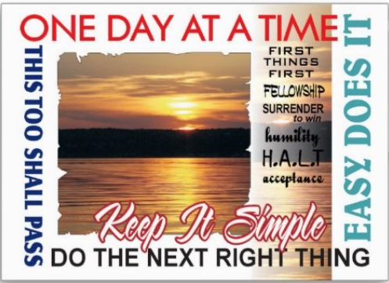
Please Join Us:
INDIAN RIVER 12 STEP STUDY GROUP’s
38th ANNIVERSARY
CELEBRATION:

Speaker: Pete W.
When: Monday, July 30, 2018
Where: Emmanuel Episcopal Church
5181 Singleton Way, Virginia Beach, VA 23452
Group Contact: 748-2914

Dinner-6:00-7:00, Speaker 7:00-8:00
Please bring a share dish, or just come to celebrate!

