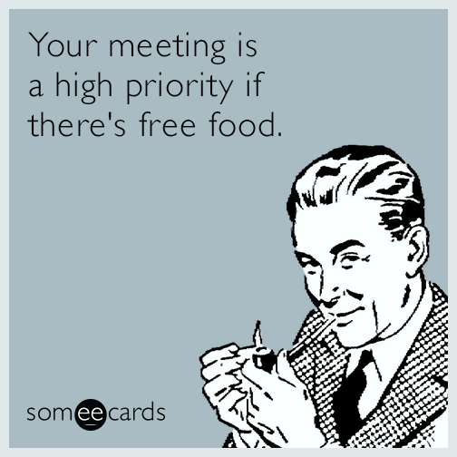
BIG BOOK IN GHENT PRESENTS:
FALL SPEAKER EVENT
Beth H. from Cary, NC
Tuesday Sept 18, 2018
5:30 potluck 6pm Speaker
Big Book in Ghent is located @ Christ and St. Luke's Episcopal Church
560 W Olney Rd, Norfolk, VA 23507

Potluck if able bring food to share

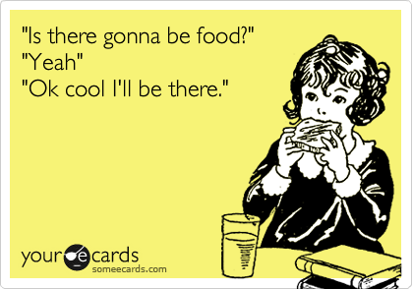
BIG BOOK IN GHENT PRESENTS:
FALL SPEAKER EVENT
Beth H. from Cary, NC
Tuesday Sept 18, 2018
5:30 potluck 6pm Speaker
Big Book in Ghent is located @ Christ and St. Luke's Episcopal Church
560 W Olney Rd, Norfolk, VA 23507
Potluck if able bring food to share

